**Abhinav Jain**

**500083840**

**EXPERIMENT 1**

**AIM: Installing Vagrant & Creating basic vagrant box using Virtual Box virtualization.**

* Check working of Vagrant using vagrant --version command.



* Create a new directory using CMD and run vagrant init command.

* Edit vagrantfile and add ubuntu/xenial64 in box tag.

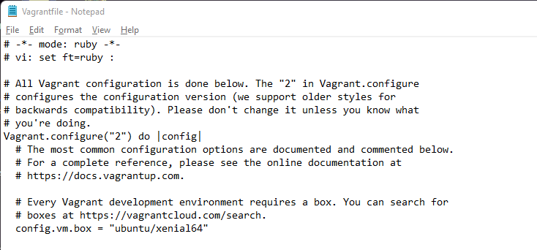

* Run vagrant up command

* Run vagrant SSH command

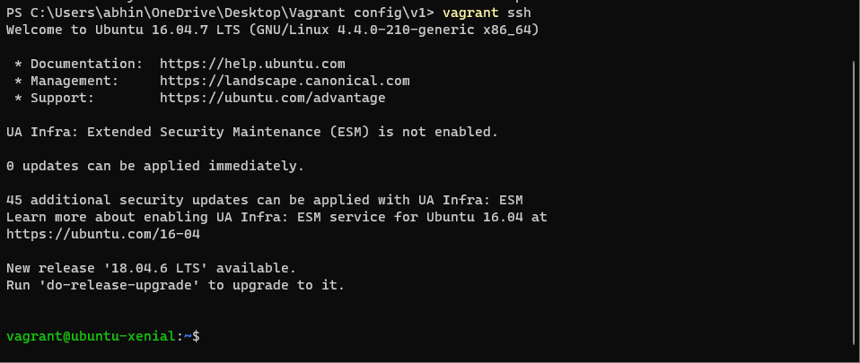

* Run Vagrant Halt to stop VM

* Run Vagrant Destroy to delete VM

